You are given the root of a binary tree. We install cameras on the tree nodes where each camera at a node can monitor its parent, itself, and its immediate children.

Return *the minimum number of cameras needed to monitor all nodes of the tree*.

**Example 1:**

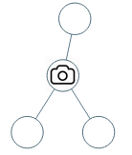

**Input:** root = [0,0,null,0,0]

**Output:** 1

**Explanation:** One camera is enough to monitor all nodes if placed as shown.

**Example 2:**

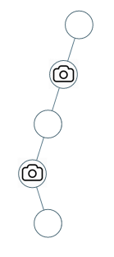

**Input:** root = [0,0,null,0,null,0,null,null,0]

**Output:** 2

**Explanation:** At least two cameras are needed to monitor all nodes of the tree. The above image shows one of the valid configurations of camera placement.

**Constraints:**

* The number of nodes in the tree is in the range [1, 1000].
* Node.val == 0